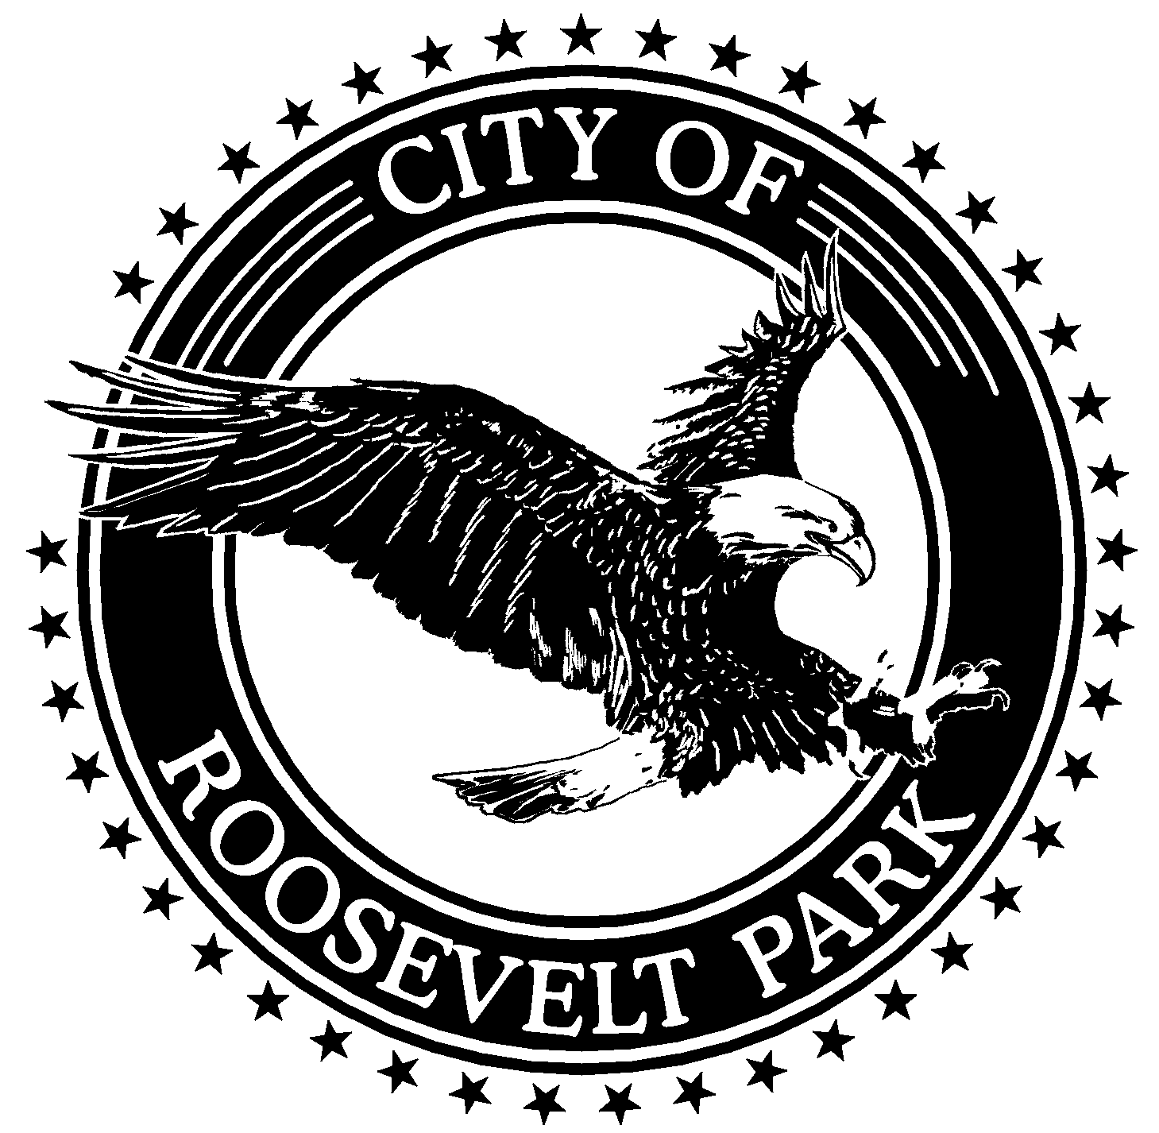CITY OF ROOSEVELT PARK

COUNCIL MEETING

COUNCIL AGENDA

September 19, 2022

6:15 P.M.

- Council Work Session
- Call to Order and Roll Call
- Pledge of Allegiance
- Invocation by Council Mayor Langlois
- Public Comment on Agenda Items

6. Approval of Consent Agenda
  - Regular Agenda
  - Minutes of the September 6, 2022, Regular City Council Meeting
  - List of Bills

    - Unfinished Business

    - New Business

  - Police Chief - Employment Agreement and Oath of Office
  - Police Sergeant - Oath of Office
  - Council Approval - Fiscal Year 2023 Police Interceptor Purchase and Outfitting
  - Resolution 22-11 - Resolution of Alternate Delegate-Dispatch Board of Directors
  - Appointment - MML Voting Delegate
  - Roosevelt Park Day Committee - Set Wrap-Up Meeting Time and Date
  - Senior Millage Ad Hoc Committee - Set Committee Meeting Time and Date
  - Fiscal Year 2022 - Third Quarter Budget Amendments

9. Public Comment
Please state your name and home address
Please limit comments to 3 minutes per individual presentation
(City Council Rules of Procedure: 10/7/2011)

10. Comments from the Mayor and City Council
11. Reports from City Manager, City Attorney & Department Heads
12. Adjournment

